2019 LUXURIOUS YOGA HOLIDAY
CAPE TOWN/ SOUTH AFRICA

Join Isabelle for a luxurious yoga holiday and discover the beauty and diversity of Cape Town and its surroundings. The retreat will combine daily yoga practice, sight seeing tours and hikes in the most stunning nature (beaches & mountains). At the same time you will experience the vibes of city life (museums, cafés & shopping).

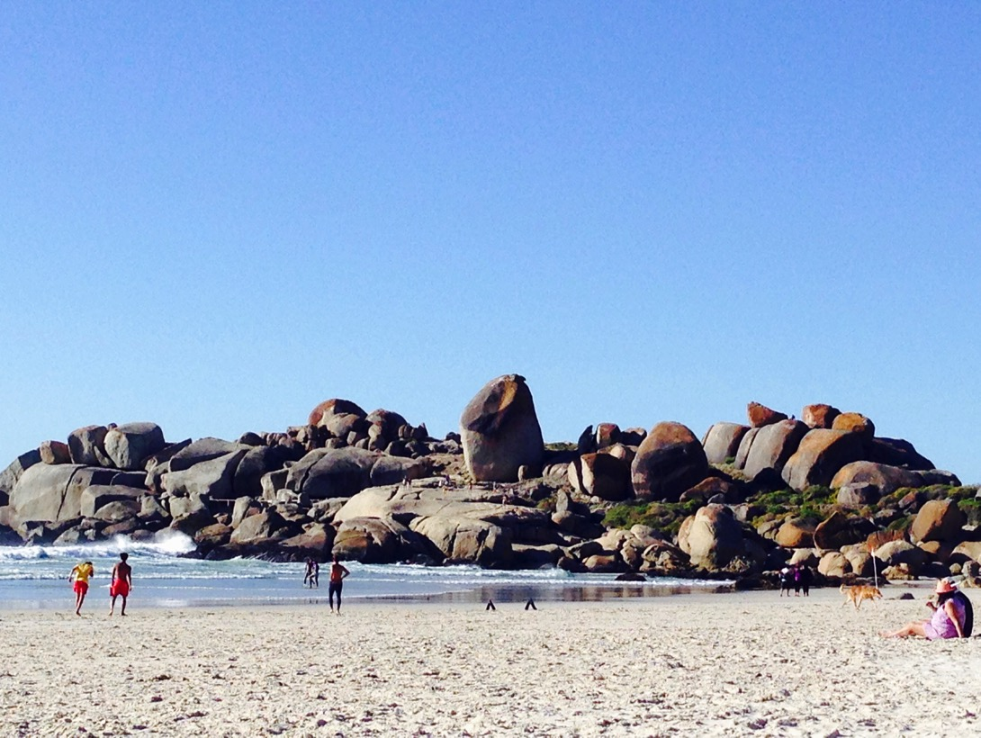

LOCATION
Our base will be a luxurious property in Bakoven with views of both the sea and mountains within walking distance to the beach.
The interior is modern with spacious twin or single bedrooms and en-suite bathrooms. There is a pool and sun deck for our yoga practice and for admiring the sunsets.
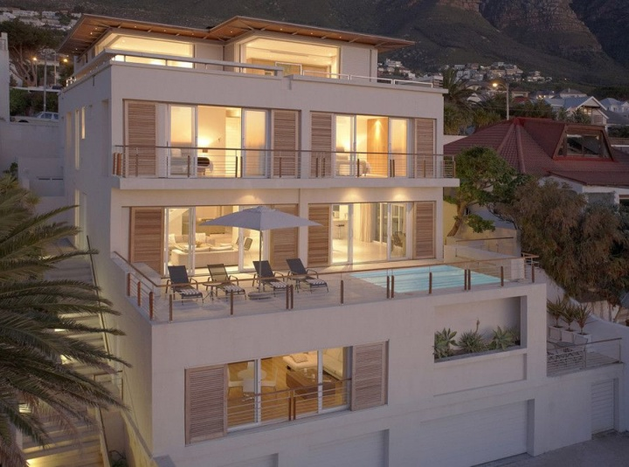
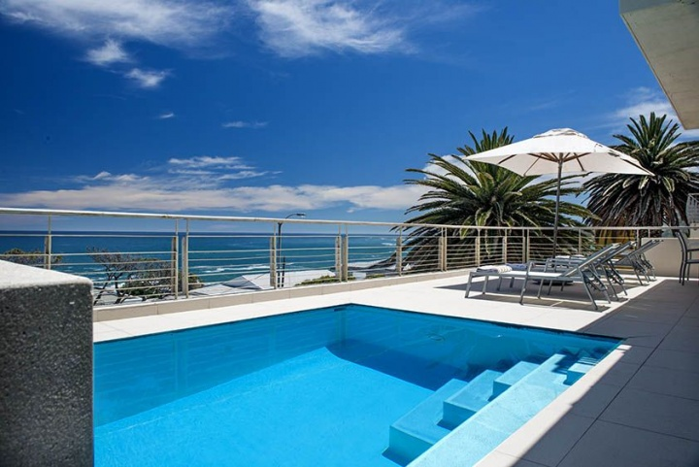

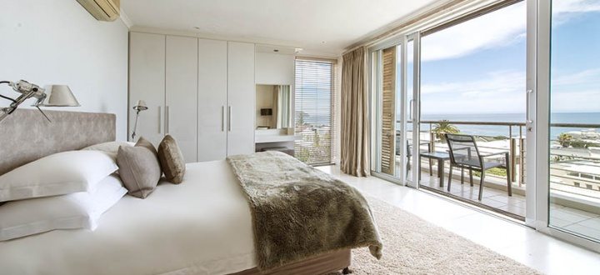

SERVICE
- 8 nights
- Daily yoga practice
- Healthy breakfast as well as delicious vegetarian meals
- Treatments with a massage therapist (not included in price)
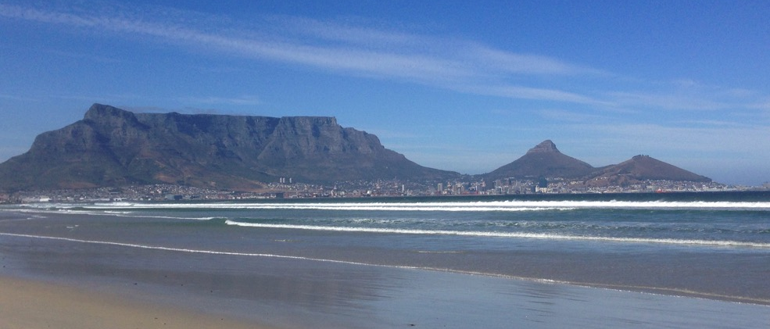

HIGHLIGHTS
- Hike around Lion’s head
- Chilling on the local beaches Llaundadno, Clifton or Camps Bay
- Daytrip to Babylonstoren in the wine area of Franschhoek
- Yoga practice with the kids from the township of Masiphumelele
- Cable car to Table Mountain for the stunning views of Cape Town
- Surf lesson or walk in Muizenberg
- Visit to the botanical garden or penguins at Boulder’s beach
- Visit to the newly opened contemporary Zeitz Mocaa Museum and/or shopping at the waterfront
- Yoga class with one of our local teachers at Exhale Yoga in Woodstock followed by a visit to the local food market

All the activities are optional, you are always welcome to stay and relax at the property. Therefore the entrance fees to the museum/ botanical garden/ cable car to Table Mountain / penguin watching at Boulder’s beach are not included in the total retreat price.
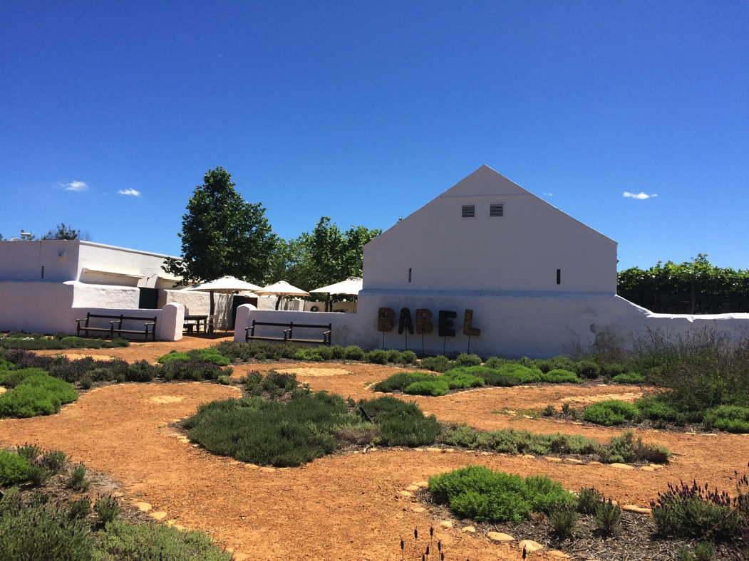

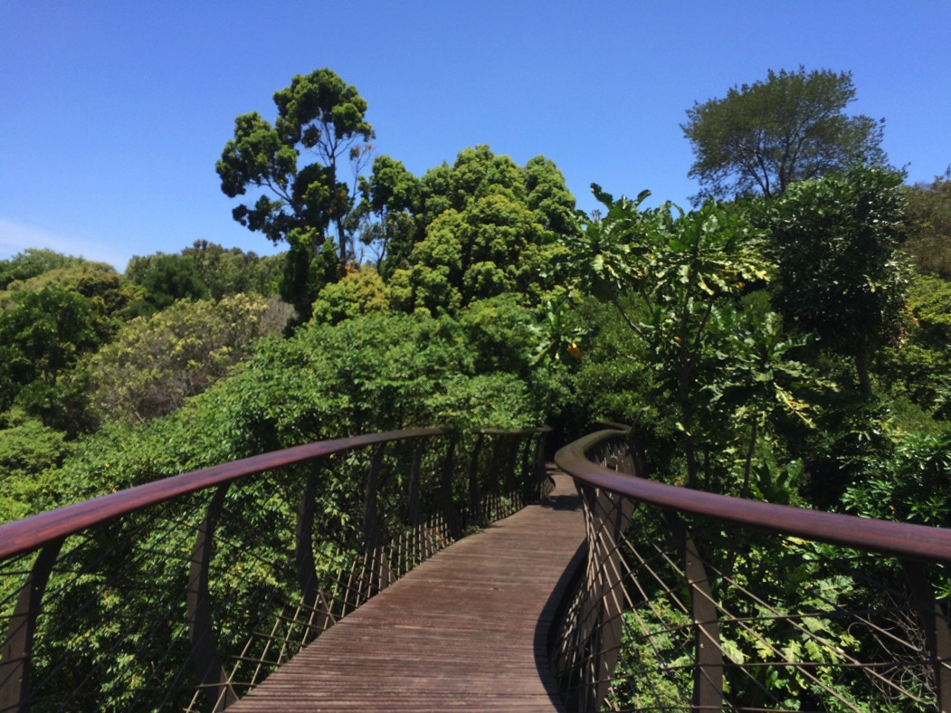
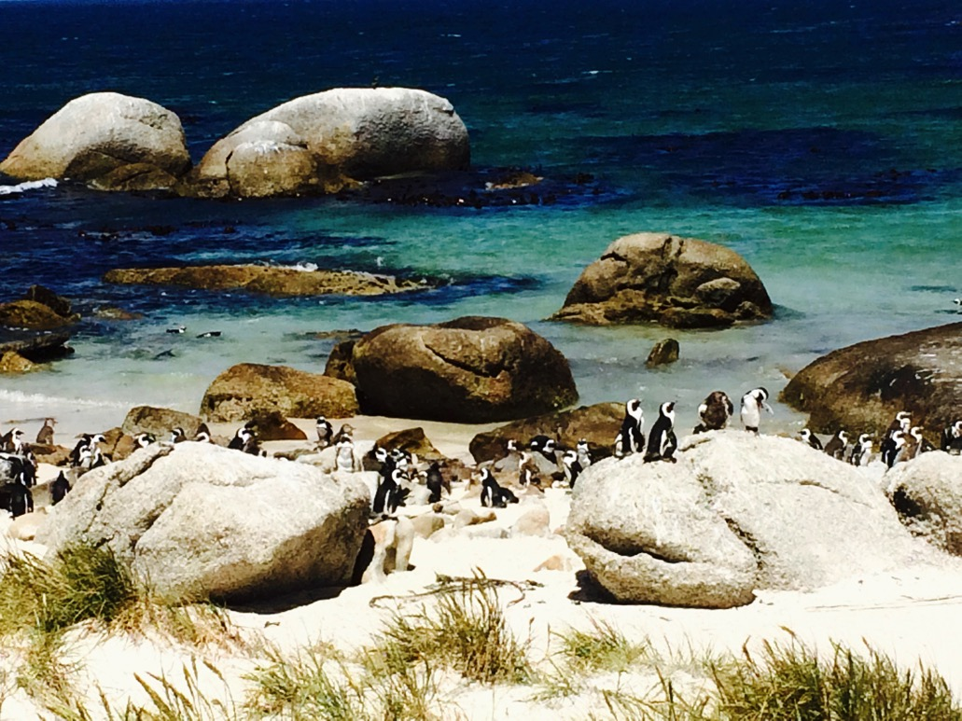

TRANSPORT AND ARRIVAL / DEPARTURE
The transportation to and from the airport as well as the transport for the excursions is included, except the flight ticket to Cape Town.
The check-in on Saturday 13th April is scheduled at 4 pm and check-out on Sunday 21st April at 10 am.
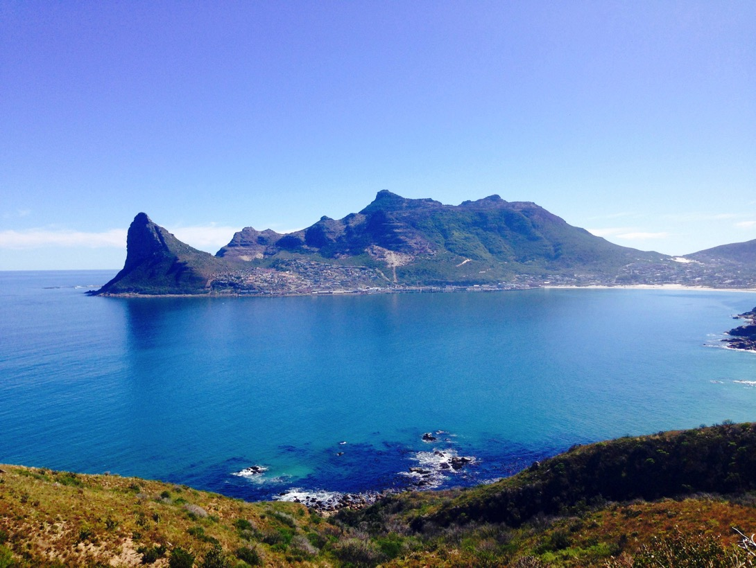

ACCOMMODATIONS / PRICE
All prices include yoga classes and food (5 lunches, 7 dinners) as well as transportation (see above). The total price of the yoga holiday is €1950 per person for a double room (occupancy for 2 persons in single beds) or €2500 per person in a single room (occupancy for 1 person in double bed).
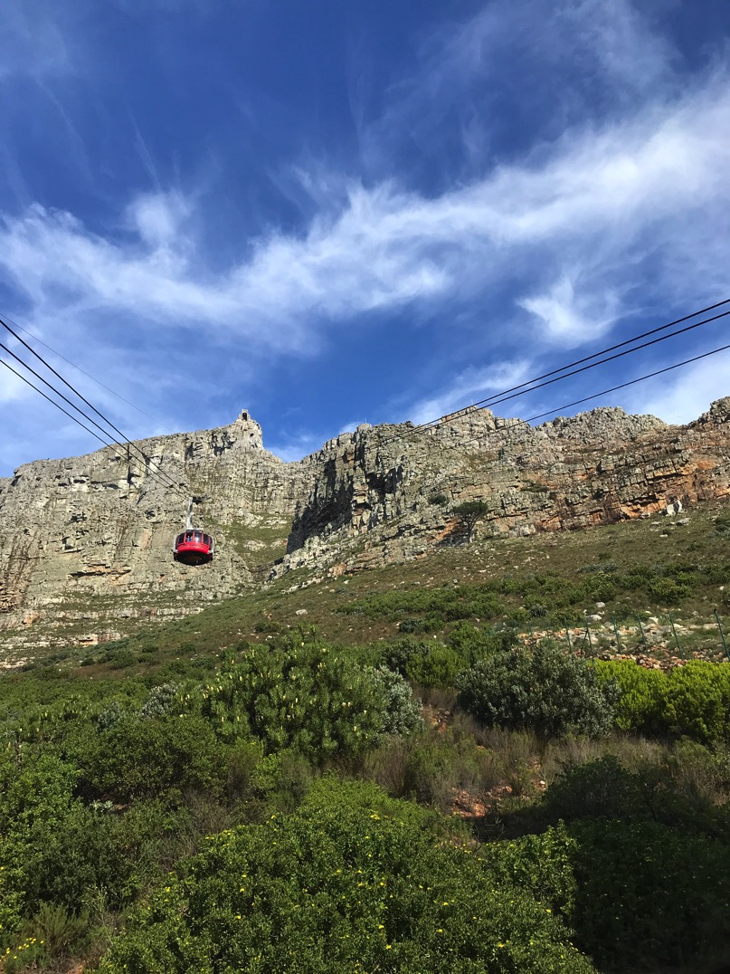
The early bird rate until November 1st 2018 is €1800 for a double room and €2350 for a single room.
BOOKING / PAYMENT
- After receipt of the registration, Exhale Yoga will send a confirmation and an invoice for the total retreat price. 60% of the invoice to be paid within 10 days of receipt and the balance to be paid at the latest 2 months before the start of the retreat (mid February).
It is advisable to have holiday insurance cover in case you have to cancel your trip.

In the event of non-payment within the requested period, your reservation will be cancelled.

There are no visa or vaccination requirements for traveling to Cape Town.

To book email Isabelle on info@exhale-capetown.co.za

ISABELLE THILL
Owner and yoga teacher at Exhale Yoga Capetown and formerly owner and yoga teacher at Yogaloft Luxembourg. Isabelle is a certified Jivamukti Yoga teacher and loves to explore different Yoga styles. In addition to Jivamukti Yoga you will experience one session of Ashtanga Yoga and Pure Flow Yoga classes (Vinyasa) with focus on various poses (backbends, inversions and twists).
All levels are welcome. Isabelle’s teaching is known to be dynamic and challenging. At the same time she encourages her students to listen to their own body and slow down the pace if necessary. Her yoga classes have a strong detoxifying effect. She will help you to go deeper in your yoga practice by giving various techniques to achieve advanced postures. Her dedication and passion for yoga is contagious.
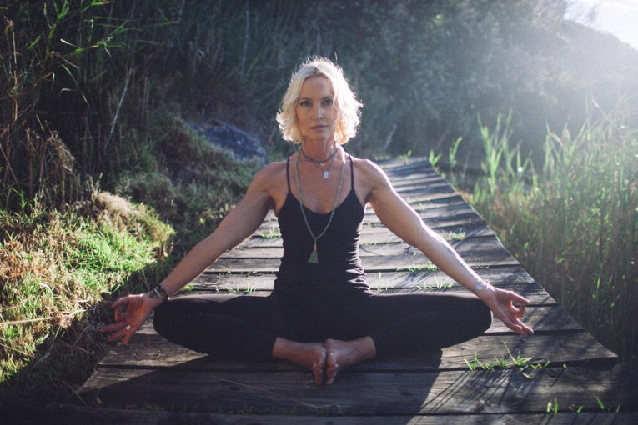
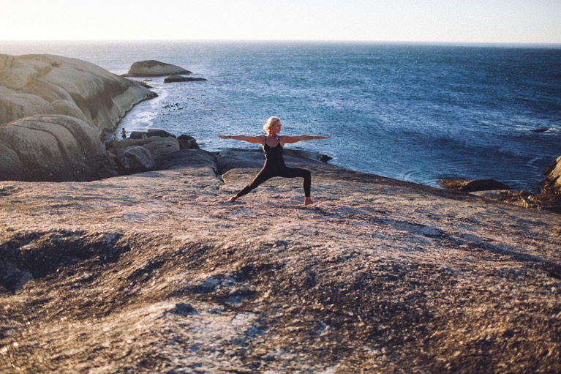

Selina Gullery

FOOD BY SELINA

I am so thrilled to have our chef Selina Gullery, whom most of you know from my previous retreats in Provence, spoiling us with her delicious vegetarian food. Selina is known for her creative intuitive cooking.

“The first yoga is food” Sri Krishnamacharya. Selina Gullery is a certified yoga teacher (500h YA, E-RYT 200). She perfected the art of intuitive cooking under the guidance of her friend and teacher Swami Samarpanananda, a Yoga master from the Himalayas. Using the principles of Ayurveda, the mindfulness of many years of meditation practice and the universal laws of love and the flow of prana, Selina bases her delicious dishes on seasonal and organic produce, mostly sourced locally.
